

Lose It! iOS App User Guide: Version 6.1.2



ANNA DUMA

Contents

Get Started 1

How Lose It! Works 1

Tools Needed 1

Lose It! Basic vs. Lose It! Premium 2

Using Lose It! 2

Create an Account 2

Add Food to Your Diary 2

Add Exercise to Your Diary 4

Add Friends 5

View or Edit Your Goal 6

Next Steps 8

Get Started

Lose It! for iOS is a tool that creates long-term weight management goals based on user data and simplifies calorie and exercise tracking for users with an extensive food and exercise database. The Lose It! iOS app offers these main features:

* Create weight management goals
* Track calories and exercise
* Track calories and exercise

This user guide will walk you through using the Lose It! iOS app to reach your weight management goals.

As with any weight loss or fitness regimen, consult a physician before you begin.

**NOTE:** This user guide assumes you have an iOS 10 device and access to the iOS App Store.

How Lose It! Works

Lose It! is a calorie and exercise tracking tool that helps users create and reach weight management goals by calculating a daily calorie budget based on user data. This daily calorie budget is used up as a user tracks calories consumed throughout the day. Weight loss occurs when a user consistently eats within the daily calorie budget. Eating above the daily calorie budget slows down weight loss progress. Lose It! increases the daily calorie budget to account for extra expended energy on days a user logs exercise.



|  |  |  |  |  |
| --- | --- | --- | --- | --- |
| **Daily calorie** | **Food** | **Exercise** | **300 Calories** |  |
| **budget** | *(1500 calories* | *(300 calories* |  |
| **remaining** |  |
|  |  |
| *(1500 calories)* | *consumed)* | *burned)* |  |
|  |  |



*Figure 1. Daily calorie budget example*

Users are responsible for tracking meals throughout the day, staying within a daily calorie budget, and accurately recording weight loss. Lose It! automatically recalculates a new daily calorie budget when a user records weight loss or edits a goal.

Tools Needed

Reaching your goals requires only a few tools.

* Lose It! – Download from the iOS App Store.
* Kitchen scale (Optional) – Weigh food to accurately estimate calories consumed.

Page | 1

Lose It! iOS App User Guide

Version 6.1.2

Lose It! Basic vs. Lose It! Premium

Lose It! Basic and Lose It! Premium have a few main features to help you create and follow through with your weight management goals. The following table compares the two versions of the app.

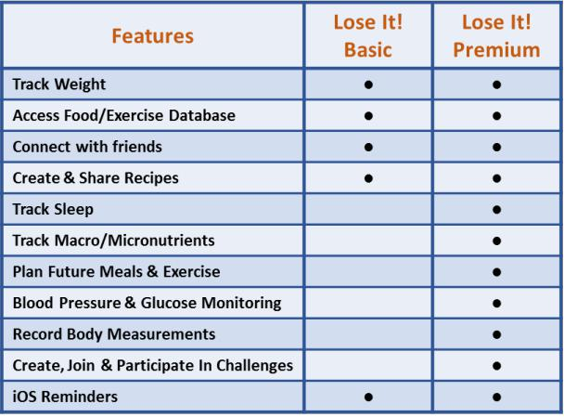

*Table 1. Compare Lose It! Basic and Premium*

Using Lose It!

Create an Account

1. Download Lose It! from the App Store.
2. Tap **Sign Up** on the home screen.
3. Enter your birthday, height, current weight, gender, and tap **Next**.
4. Enter your goal weight, choose how quickly you want to reach this goal, and tap **Next.**
5. Enter an email address, password, and tap **Next**.

Your Lose It! account has now been created, and you are ready to begin tracking your food and exercise.

Add Food to Your Diary

You are ready to begin logging your meals. You can add food to any meal by searching the Lose It! food database for any food item.

1. Tap on **Log** to open the page where you will add food to your diary.

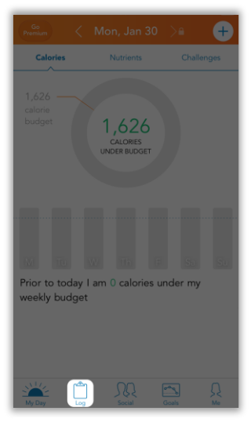

*Figure 2. Log tab*

Page | 2

Lose It! iOS App User Guide Version 6.1.2

1. Tap the camera icon or the ic on to add food to a meal.

**NOTE:** Tapping the camera icon will open your camera application and Lose It! will use its Snap It!beta feature to take a picture and estimate the calories in the food item.

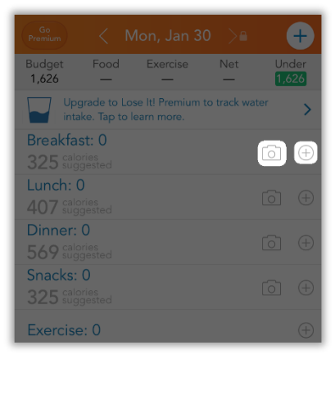

*Figure 3. Tap icon next to meal*

1. Tap on any of the following to begin searching the food database for food:

* **Search** to search the general Lose It! database
* **My Foods** to search and add individual items from your history
* **Meals** to search and add previous meals
* **Recipes** to search and add an existing recipe

**TIP:** Tap **Create Recipe** to add a customized recipe to your profile

* **Brands** to search for food by brand name
* **Scan a food item** or the blue barcode button to add food to your diary by scanning its barcode
* **Create New Food** to create a new food item and manually enter nutritional facts
* **Add Calories** to enter calories without searching or creating a new food item

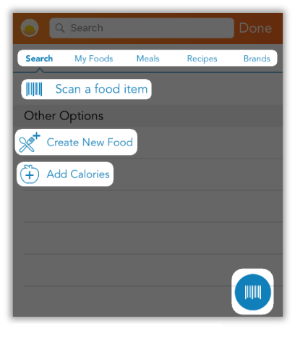

*Figure 4. Tap a search option*

Page | 3

Lose It! iOS App User Guide

Version 6.1.2

1. Type your food item in the search bar. Tap on the correct food item, scroll to select the quantity of food, and tap **Add.**

**NOTE:** Lose It! has a large database with multiple variations of the same item. Use a kitchen scaleto weigh your food, or select the closest item based on the size or quantity of your item.

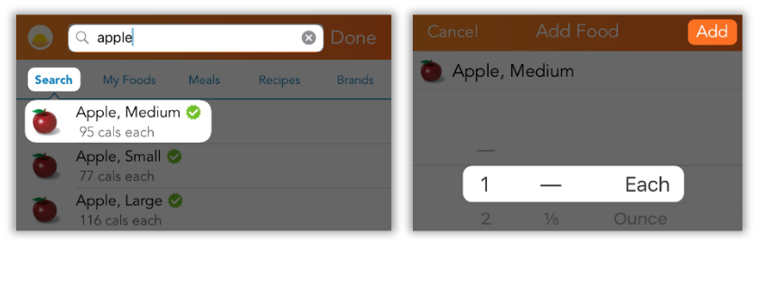

*Figure 5. Search for food*

1. Repeat *Step 4* to add more food items to your meal, and tap **Done** when finished.
2. Tap **I’ve logged everything** at the end of each day, and tap **My Day** if you would like to view your daily and weekly calorie and nutrients details.

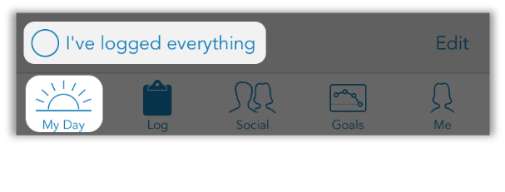

*Figure 6. Finish logging food*

You have now successfully added food to your daily diary, and you are well on your way to managing your eating habits with Lose It!.

Add Exercise to Your Diary

Lose It! has a large exercise database to help you track your daily physical activity and accurately estimate calories burned. Remember that every time you log calories burned, Lose It! recalculates your daily calorie budget to account for expended energy.

1. On your **Log** tab, tap on theicon.

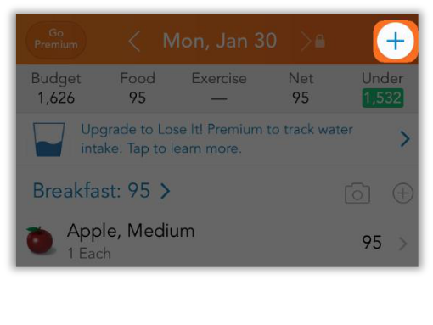

*Figure 7. Add exercise*

Page | 4

Lose It! iOS App User Guide

Version 6.1.2

1. Tap on **Exercise**

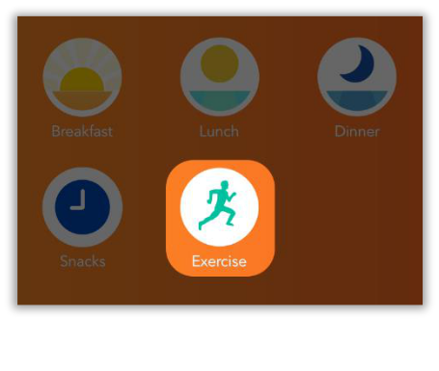

*Figure 8. Exercise*

1. Tap **Browse Exercises** to choose an exercise. Enter the amount of effort exerted, duration of activity, and tap **Add.**

**TIP:** Tap **My Exercises** for quick access to all exercises previously added to your diary.

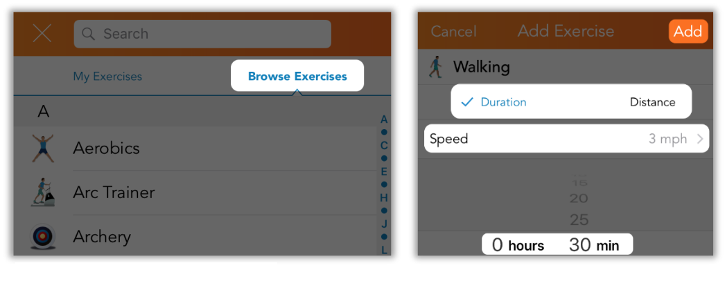

*Figure 9. Exercise database and details*

You have now successfully added exercise to your daily diary, and you are well on your way to reaching your goals with Lose It!.

Add Friends

Lose It! allows you to add friends to help you challenge yourself and stay motivated. Use this feature to track a friend’s progress and compare it to your own.

1. In the **Social** tab, tap **Friends**, and the + icon to add friends.

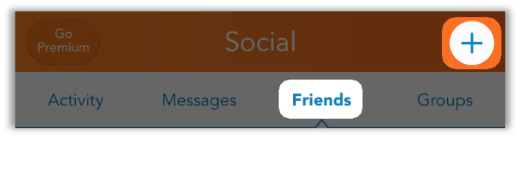

*Figure 10. Social tab*

Page | 5

Lose It! iOS App User Guide

Version 6.1.2

1. Tap on **Add Friend** and enter their Lose It! registered email address, then tap **Add**. Your friend must accept your friend request for you to view their profile and progress.

**NOTE:** You can tap **Find Group** to search for and join communities made up of Lose It! users withsimilar interests to yourself.

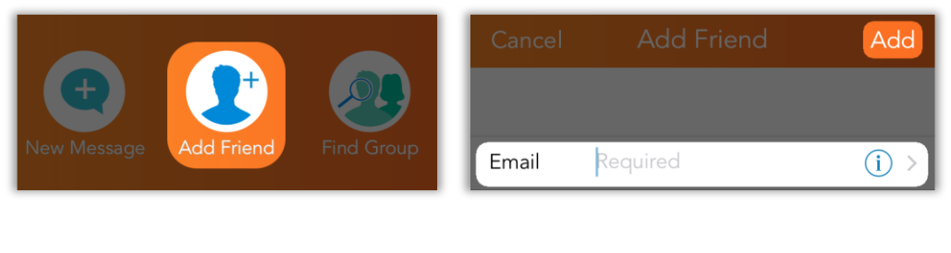

*Figure 11. Add friends*

1. Tap **Social** > **Friends** to see a list of your Lose It! friends, and tap on a profile to view their statistics, goals, and progress.

You have now successfully added friends to your Lose It! profile. Visit their profiles to compare progress and keep yourself motivated.

View or Edit Your Goal

When you created a Lose It! account, you provided the app your age, height, current weight, gender, and your desired goal. Lose It! took this information and created a plan to help you lose weight. You may want to reach your goal sooner than expected, or delay reaching your goal for a little longer. Use the steps below as a guide for how to view and edit your Lose It! goal.

1. Tap on **Goals** to view your current goal, and tap **Weight** to view your projected goal completion date.

**TIP:** The **Goals** tab shows you a graph of your current weight loss progress and is a greatvisualization of your overall progress.

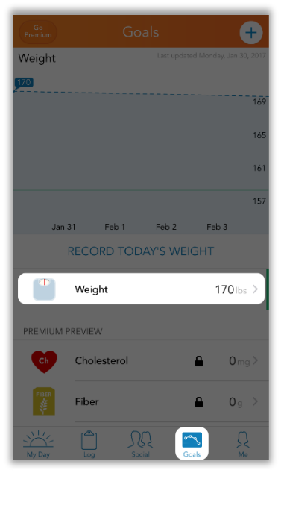

*Figure 12. Progress details*

Page | 6

Lose It! iOS App User Guide

Version 6.1.2

2. Tap **RECORD TODAY’S** **WEIGHT**, enter your current weight, and tap **Save**.

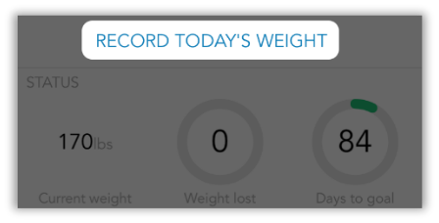

*Figure 13. Record current weight*

1. Tap **Edit** to view your current goal.
2. Tap **My Plan** to make changes to your current goal. Tap on any other field to make changes to the data, if necessary.

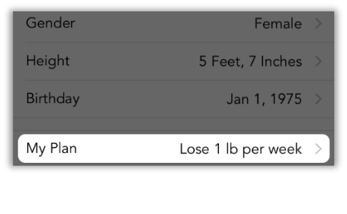

*Figure 14. View your plan*

1. Tap on any field to change the amount of weight you want to lose per week.

**TIP:** Lose It! will automatically recalculate your daily calorie budget and overall goal completiondate.

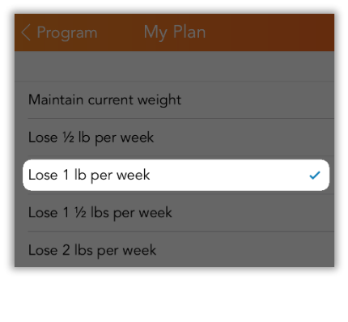

*Figure 15. Change your goal*

6. Tap **Program** > **Weight** > **Goals** to return to the main goals page.

You have now successfully edited your Lose It! goals, and you are well on your way to reaching your weight loss goals with Lose It!.

Page | 7

Lose It! iOS App User Guide

Version 6.1.2

Next Steps

With the Lose It! app, you now have the tool needed to create weight management goals and track your progress. Continue using Lose It! track your calories until you reach your goal, and even after to maintain your goal weight. Here are a few tips for success:

* *Start now*: the sooner you set your goals and begin working toward them, the sooner you will reach your goals.
* *Do not let a setback ruin your progress*: some days you may eat more than your daily caloriebudget. Try to get back on track with your next meal and do not let a few lapses prevent you from continuing.
* *Do not give up*: track your calorie intake for every meal until it becomes part of your routine. Onceyou have reached your goals, continue using Lose It! to maintain your goal weight.

Congratulations on taking the first steps to a healthier life!

*Visit* [*https://www.loseit.com*](https://www.loseit.com/) *to learn more.*

Page | 8

Lose It! iOS App User Guide

Version 6.1.2